*Sent to all Members*  
  
June 2, 2024  
  
Dear {%FName%},

Rotary Minutes are provided by District 6220 Governor-Elect Roger Utnehmer (Oot-name-er). Please read at club meetings and post in newsletters and social media.

===========================================================

“This is a Rotary Foundation Minute from District Governor-Elect Roger Utnehmer (Oot-name-er).

The 2024 Rotary International Conference is ending in Singapore and I prepare to return home honored, humbled and gratified.

Honored, because I had an opportunity to share the story of District 6220’s Cultural Appreciation Initiative Outreach to American Indians at a session attended by more than 700 Rotarians from throughout the world.

Many who may misunderstand the goals of Diversity, Equity and Inclusion embrace Cultural Appreciation. I was humbled by the number of Rotarians who requested the Indigenous land acknowledgment statement clubs in 6220 are encouraged to use at the start of Rotary meetings. This is practiced throughout Australia and New Zealand and is becoming common in the United States.

Inviting those underrepresented in Rotary to speak to us, pursue joint service projects and apply for youth exchange program participation resonated with Rotarians from diverse cultures.

I leave Singapore with pride in the reality that engaged Rotarians become citizens of the world.

I am grateful for the experience and proud of the opportunity presented.

May you be as proud to be a member of Rotary International as I.

This has been a Rotary Minute.”

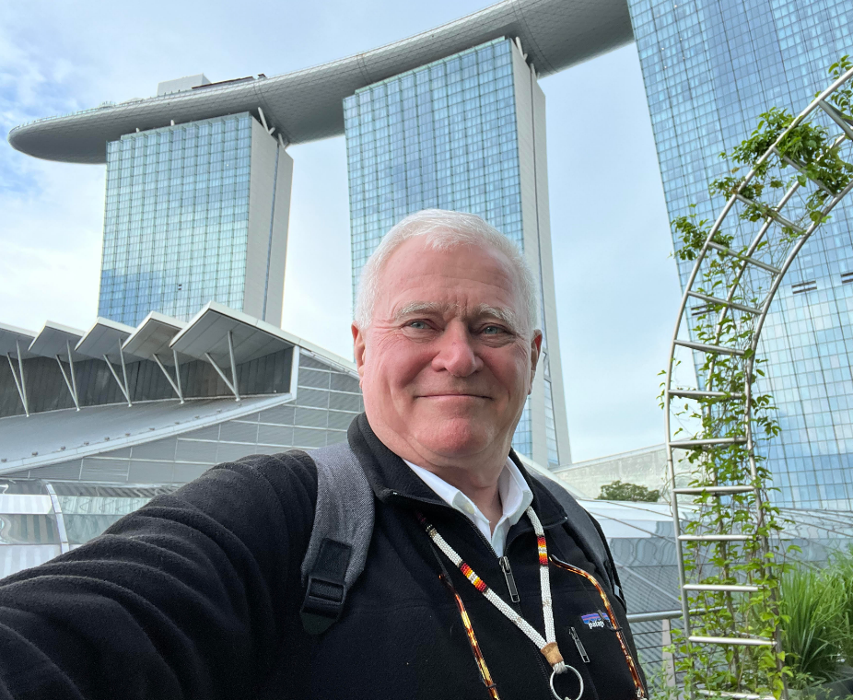

Roger Utnehmer    
Rotary District 6220 PHS Coordinator   
District Governor 2024-25   
(C) 920 495 9677   
[utnehmer@gmail.com](mailto:utnehmer@gmail.com)